SUPPORTING INFORMATION

Light-Modulated Rheological Properties in Green Innovative Formulations

Duccio Tatini,* Martina Raudino and Filippo Sarri
Department of Chemistry “Ugo Schiff” and CSGI, University of Florence, Via della Lastruccia 3, 50019 Sesto Fiorentino (Firenze), Italy
E-mail: duccio.tatini@unifi.it

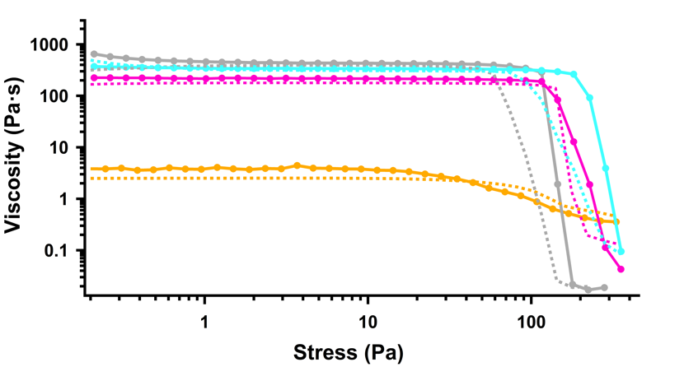
Steady-state Rheology
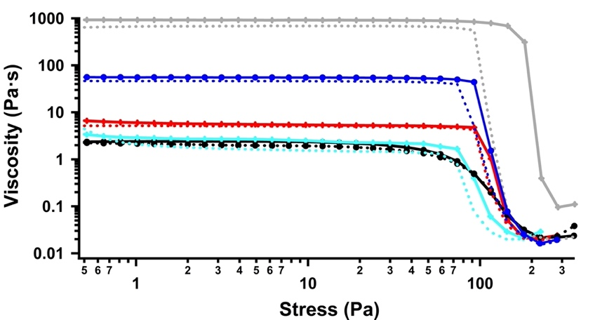
Figure S1. Flow Curves before (solid lines) and after (dashed lines) UV irradiation for NaOL 0.43 M mixture in the presence of KCl at 0.1 % (orange), 1% (grey), 3.5 % (light blue) and 4 % (pink).
Figure S2. Flow Curves before (solid lines) and after (dashed lines) UV irradiation for NaOL 0.43 M mixture in the presence of azorubine 0.18 % at different concentration of KCl: 0 (black), 0.1 % (orange), 1% (grey), 3 % (red) and 3.5 % (light blue).
 | Table S1. Zero-shear rate viscosity η₀ , infinite rate viscosity η∞ , Cross time constant C (s), shear relaxation exponent m and R² obtained by fitting the experimental viscosity data with the Cross model. The values for non-irradiated NaOL+KCl dispersions are reprinted from [1] with permission from Elsevier.
 |  | η₀ (Pa∙s) | η∞(Pa∙s) | C (s) | m | R²
NaOL  0.43 M* | No KCl | 0.72 | 0.011 | 1.82∙10⁻⁴ | 1.01 | 0.988
 | KCl  0.1 % | 3.91 | 0.24 | 2.09 | 0.73 | 9.998
 | KCl  0.5 % | 27.86 | 0.008 | 0.211 | 0.98 | 0.999
 | KCl  1 % | 443.4 | 0.014 | 1.33 | 1.18 | 0.999
 | KCl  2 % | 1051 | 0.037 | 2.54 | 1.08 | 0.999
 | KCl  3 % | 486.8 | 0.053 | 1.133 | 1.08 | 0.999
 | KCl  3.5 % | 351.4 | 0.052 | 0.765 | 1.13 | 0.999
 | KCl  4 % | 228.0 | 0.025 | 0.813 | 1.05 | 0.998
NaOL  0.43 M  UV Irradiation | No KCl | 1.12 | 0.036 | 1.01∙10⁻³ | 1.17 | 0.996
 | KCl  0.1 % | 2.54 | 0.029 | 1.23∙10⁻³ | 1.20 | 0.995
 | KCl  0.5 % | 24.74 | 0.005 | 0.185 | 0.97 | 0.999
 | KCl  1 % | 427.0 | 0.011 | 3.6 | 1.03 | 0.999
 | KCl  2 % | 886.7 | 0.024 | 7.01 | 0.918 | 0.999
 | KCl  3 % | 297.8 | 0.014 | 1.78 | 0.965 | 0.999
 | KCl  3.5 % | 295.9 | 0.021 | 0.963 | 0.995 | 0.999
 | KCl  4 % | 185.01 | 0.034 | 0.101 | 1.31 | 0.999
NaOL  0.43 M  Azorubine  0.18 % | No KCl | 2.501 | 0.014 | 0.020 | 1.03 | 0.999
 | KCl  0.1 % | 6.935 | 0.012 | 0.060 | 1.01 | 0.998
 | KCl  0.5 % | 278.8 | 0.022 | 1.83 | 1.05 | 0.999
 | KCl  1 % | 951.8 | 0.038 | 2.50 | 1.08 | 0.999
 | KCl  2 % | 57.98 | 0.012 | 0.251 | 1.13 | 0.998
 | KCl  3 % | 5.722 | 0.106 | 0.025 | 1.24 | 0.998
 | KCl  3.5 % | 2.661 | 0.014 | 0.017 | 1.17 | 0.999
 | KCl  4 % | 1.852 | 0.016 | 0.008 | 1.37 | 0.999
NaOL  0.43 M  Azorubine 0.18 %  UV Irradiation | No KCl | 2.074 | 0.016 | 0.016 | 1.028 | 0.997
 | KCl  0.1 % | 13.6 | 0.025 | 0.147 | 1.09 | 0.999
 | KCl  0.5 % | 728.3 | 0.002 | 14.01 | 0.873 | 0.999
 | KCl  1 % | 736.7 | 0.014 | 3.07 | 1.11 | 0.999
 | KCl  2 % | 53.44 | 0.012 | 0.289 | 1.09 | 0.998
 | KCl  3 % | 5.205 | 0.016 | 0.019 | 1.34 | 0.999
 | KCl  3.5 % | 2.01* | 0.015* | 0.010* | 1.30* | 0.999*
 | KCl  4 % | 730.1 | 0.009* | 0.015* | 0.96* | 0.999*
 | *: data from [1]
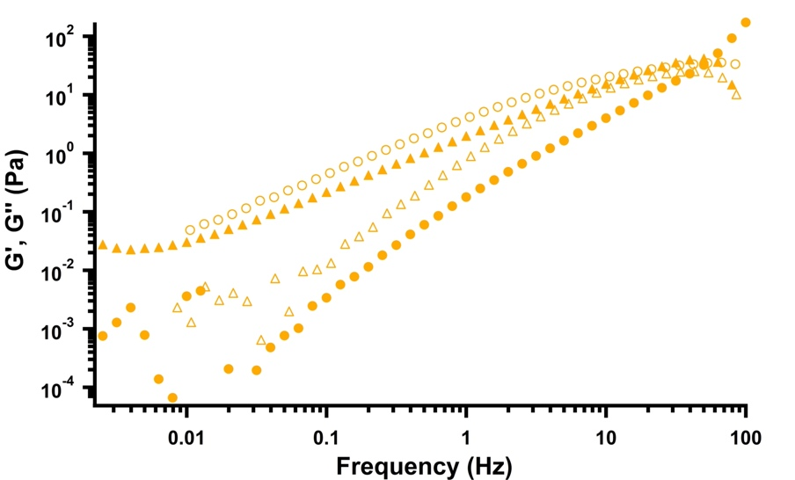
Oscillatory Measurements

Figure S3. Storage (triangles) and loss (circles) moduli before (filled markers) and after (hollow markers) UV irradiation for NaOL 0.43 M mixture in the presence of KCl at 0.1 %.

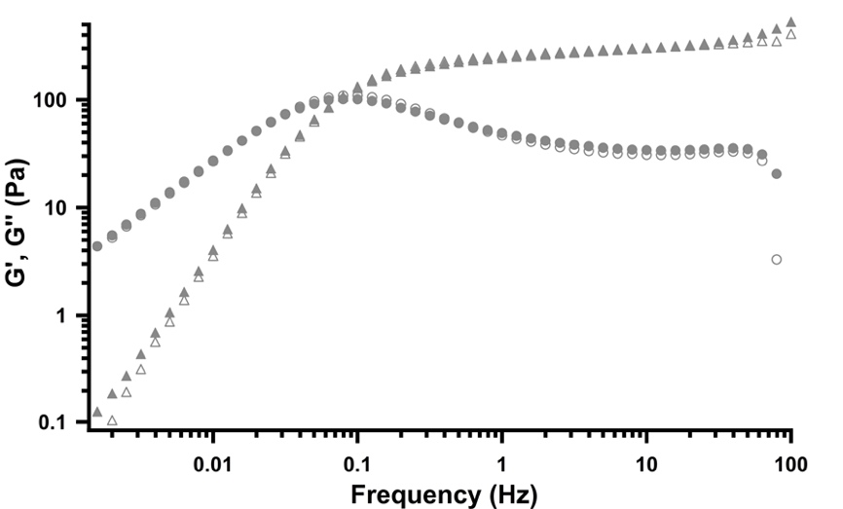
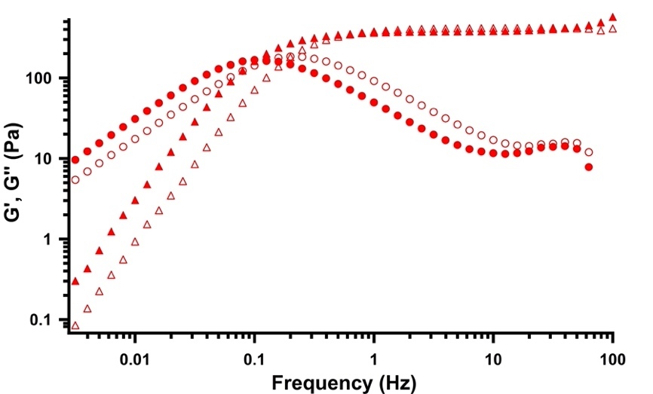
Figure S4. Storage (triangles) and loss (circles) moduli before (filled markers) and after (hollow markers) UV irradiation for NaOL 0.43 M mixture in the presence of KCl at 1 %.
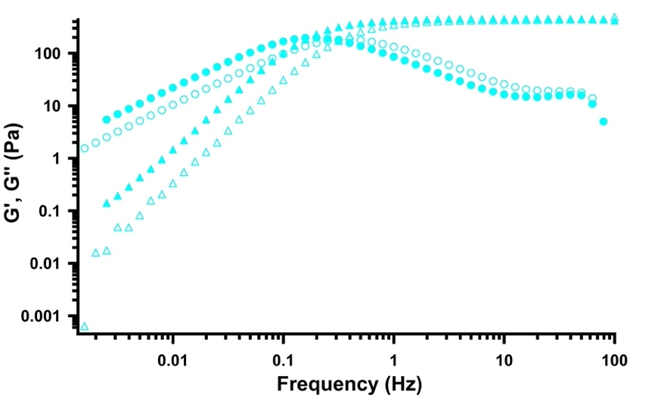
Figure S5. Storage (triangles) and loss (circles) moduli before (filled markers) and after (hollow markers) UV irradiation for NaOL 0.43 M mixture in the presence of KCl at 3 %.
Figure S6. Storage (triangles) and loss (circles) moduli before (filled markers) and after (hollow markers) UV irradiation for NaOL 0.43 M mixture in the presence of KCl at 3.5 %.
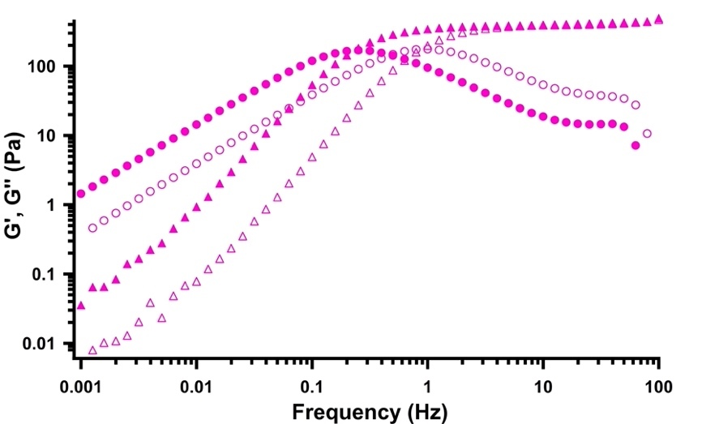
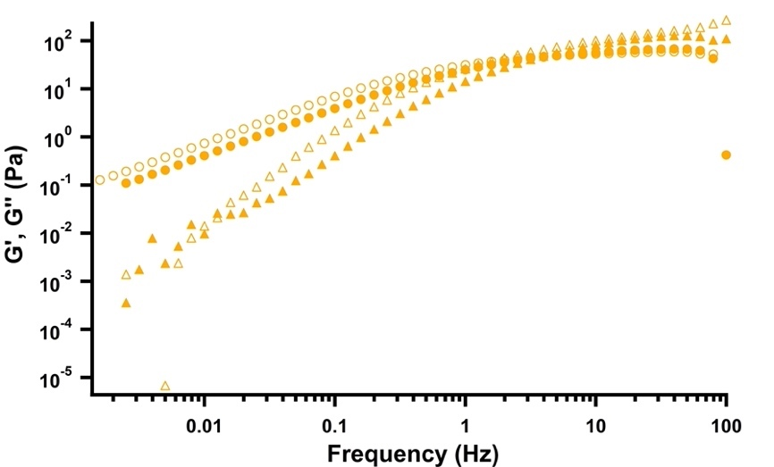
Figure S7. Storage (triangles) and loss (circles) moduli before (filled markers) and after (hollow markers) UV irradiation for NaOL 0.43 M mixture in the presence of KCl at 4 %.
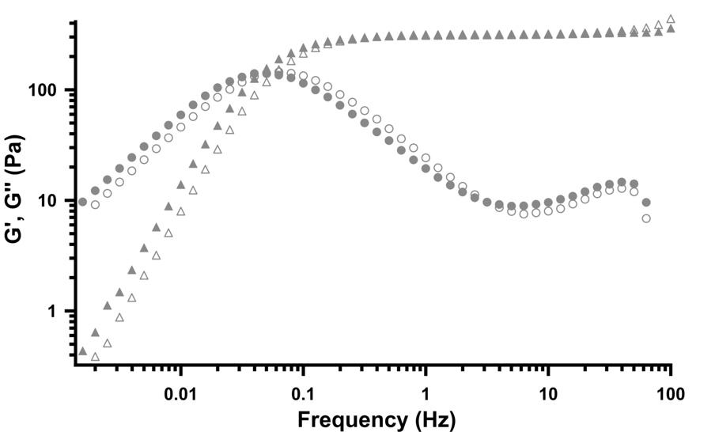
Figure S8. Storage (triangles) and loss (circles) moduli before (filled markers) and after (hollow markers) UV irradiation for NaOL 0.43 M + azorubine 0.18 % mixture in the presence of KCl at 0.1 %. Figure S9. Storage (triangles) and loss (circles) moduli before (filled markers) and after (hollow markers) UV irradiation for NaOL 0.43 M + azorubine 0.18 % mixture in the presence of KCl at 1 %.

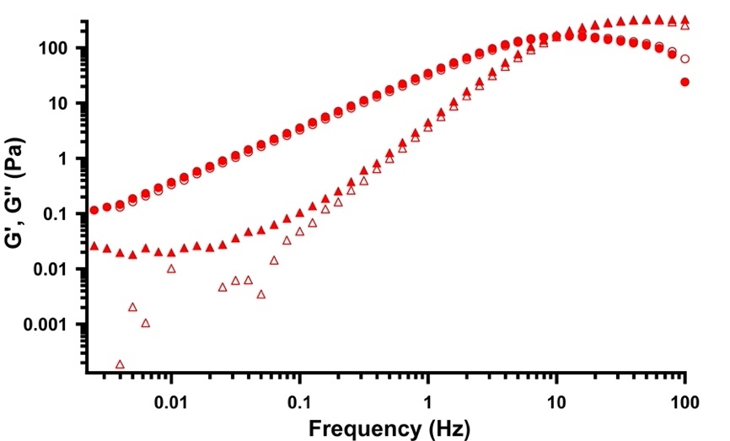
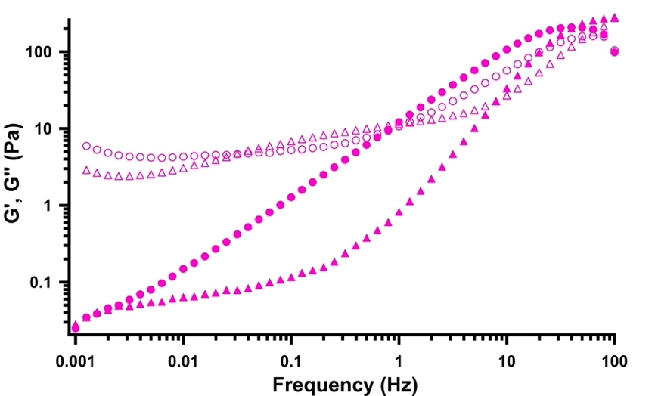
Figure S10. Storage (triangles) and loss (circles) moduli before (filled markers) and after (hollow markers) UV irradiation for NaOL 0.43 M + azorubine 0.18% mixture in the presence of KCl at 4 %.
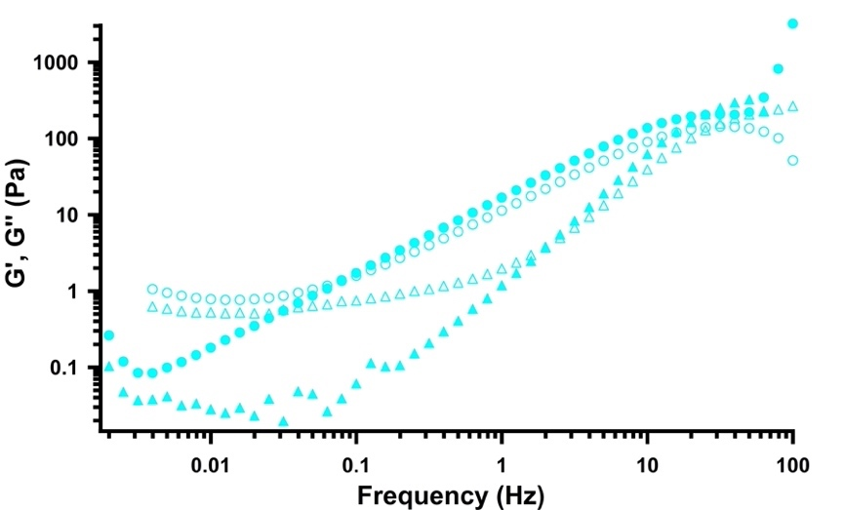
Figure S11. Storage (triangles) and loss (circles) moduli before (filled markers) and after (hollow markers) UV irradiation for NaOL 0.43 M + azorubine 0.18 % mixture in the presence of KCl at 3 %. Figure S12. Storage (triangles) and loss (circles) moduli before (filled markers) and after (hollow markers) UV irradiation for NaOL 0.43 M + azorubine 0.18 % mixture in the presence of KCl at 3.5 %.

DSC
Table S2. Melting temperature, the relative enthalpy change and amount (%) of free water (${∆H}_{mf}$, $T_{mf}$ and $W_{f}$), interfacial water (${∆H}_{mi}$, $T_{mi}$and $W_{i}$) and freezable bound water (${∆H}_{mb}$, $T_{mb}$and $W_{b})$ for all the examined samples, before and after UV irradiation. The values for non-irradiated NaOL+KCl dispersions are reprinted from [1] with permission from Elsevier.
 |  | ΔH_{mf} (J/g) | T_{mf} (°C) | W_{f} (%) | ΔH_{mi} (J/g) | T_{mi} (°C) | W_{I} (%) | ΔH_{mb} (J/g) | T_{mb} (°C) | W_{b}(%)
NaOL  0.43 M* | No KCl | 319.9 | 2.50 | 95.8 | - | - | - | - | -
 | KCl  0.1 % | 300.2 | 1.97 | 89.9 | - | - | - | - | -
 | KCl  0.5 % | 286.5 | 1.30 | 85.8 | 1.221 | -14.67 | 0.4 | - | -
 | KCl  1 % | 232.5 | 1.69 | 70.0 | 8.367 | -12.88 | 2.7 | - | -
 | KCl  2 % | 217.7 | 0.39 | 65.2 | 18.22 | -11.58 | 5.8 | - | -
 | KCl  3 % | 169.6 | 0.12 | 50.8 | 21.66 | -11.02 | 6.9 | - | -
 | KCl  3.5 % | 163.3 | -0.94 | 48.9 | 27.47 | -11.22 | 8.8 | - | -
 | KCl  4 % | 152.8 | -1.06 | 45.8 | 25.16 | -11.45 | 8.1 | 3.507 | -22.69 | 1.12
NaOL  0.43 M  UV Irradiation | No KCl | 314.7 | 1.85 | 94.3 | - | - | - | - | -
 | KCl  0.1 % | 305.2 | 1.54 | 91.4 | - | - | - | - | -
 | KCl  0.5 % | 288.0 | 1.57 | 86.3 | 2.899 | -15.44 | 0.9 | - | -
 | KCl  1 % | 269.4 | 0.14 | 81.0 | 8.0296 | -13.53 | 2.6 | - | -
 | KCl  2 % | 231.2 | -0.39 | 69.2 | 18.39 | -12.25 | 5.9 | - | -
 | KCl  3 % | 178.2 | -0.72 | 53.4 | 25.52 | -11.54 | 8.2 | - | -
 | KCl  3.5 % | 161.7 | -1.16 | 48.4 | 26.78 | -11.52 | 8.6 | - | -
 | KCl  4 % | 153.2 | -1.06 | 45.9 | 19.85 | -12.06 | 6.4 | 2,433 | -23.90 | 0.78
NaOL  0.43 M  Azorubine 0.18 % | No KCl | 312.4 | 2.33 | 93.6 | - | - | - | - | - | -
 | KCl  0.1 % | 310.1 | 1.54 | 92.9 | - | - | - | - | - | -
 | KCl  0.5 % | 288.5 | 1.18 | 86.4 | 2.112 | -17.61 | 0,68 | - | - | -
 | KCl  1 % | 266.4 | 0.46 | 79.8 | 6.545 | -14.54 | 2,10 | - | - | -
 | KCl  2 % | 209.0 | 1.79 | 62.6 | 11.05 | -12.08 | 3,54 | - | - | -
 | KCl  3 % | 183.4 | -0.12 | 54.9 | 17.24 | -11.99 | 5,52 | 1.715 | -23.70 | 1,72
 | KCl  3.5 % | 163.2 | -0.65 | 48.9 | 19.95 | -11.69 | 6,39 | 0.7329 | -25.81 | 0,73
 | KCl  4 % | 167.4 | -1.28 | 50.2 | 23.64 | -12.16 | 7,57 | 3.666 | -24.01 | 3,67
NaOL  0.43 M  Azorubine 0.18 %  UV Irradiation | No KCl | 313.6 | 1.52 | 94,0 | - | - | - | - | - | -
 | KCl  0.1 % | 312.5 | 0.85 | 93,6 | - | - | - | - | - | -
 | KCl  0.5 % | 306.8 | 0.72 | 91,9 | - | - | - | - | - | -
 | KCl  1 % | 271.9 | 0.13 | 81,5 | 6.591 | -14.72 | 2,11 | - | - | -
 | KCl  2 % | 231.3 | -0.45 | 69,3 | 14.92 | -12.75 | 4,78 | - | - | -
 | KCl  3 % | 186.1 | -0.46 | 55,8 | 15.70 | -12.16 | 5,03 | 1.843 | -23.94 | 0,59
 | KCl  3.5 % | 182.7 | -1.18 | 54,7 | 20.47 | -12.40 | 6,56 | 1.396 | -24.42 | 0,45
 | KCl  4 % | 153.2 | -1.06 | 45,9 | 19.85 | -12.06 | 6,36 | 2.433 | -23.90 | 0,78
*: data from [1]

Figure S13. DSC thermograms before (solid lines) and after (dashed lines) UV irradiation for NaOL 0.43 M mixture at different concentration of KCl: 0.1 % (orange), 0.5 % (green), 1 % (grey), 2 % (blue) and 3 % (red).
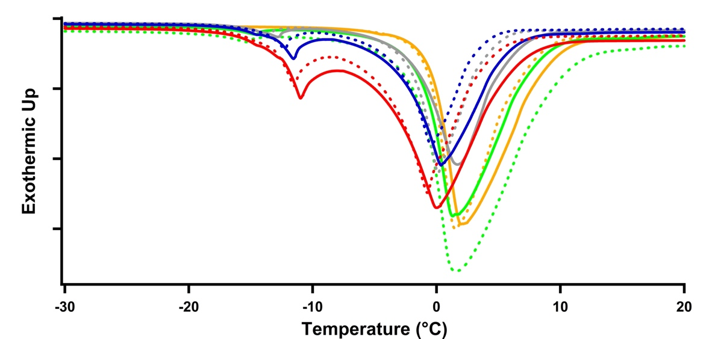

References
[1] D. Tatini, M. Raudino, M. Ambrosi, E. Carretti, I. Davidovich, Y. Talmon, B.W. Ninham, P. Lo Nostro, Physicochemical characterization of green sodium oleate-based formulations. Part 1. Structure and rheology, J. Colloid Interface Sci. 590 (2021) 238–248. https://doi.org/10.1016/j.jcis.2021.01.040.

