**A facile synthesis of montmorillonite supported CdAl2O4 nanocomposites with photocatalytic and hydrophobic properties**

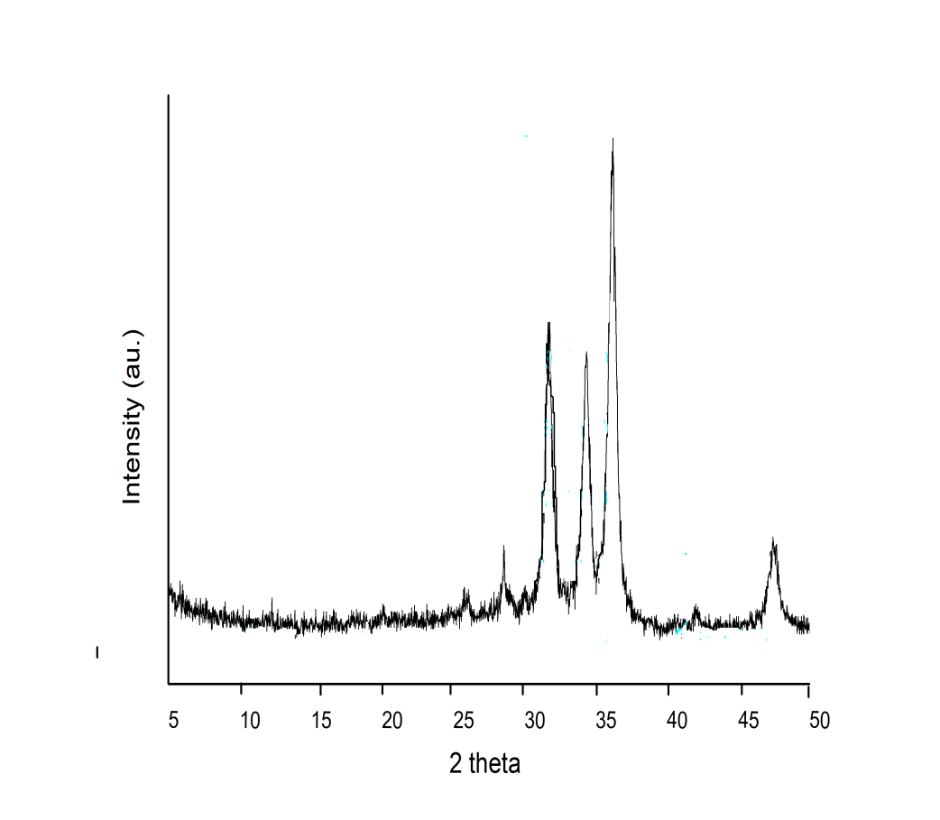

**Fig. SI 1**. XRD pattern of 9% wt Montmorillonite clay supported CdAl2O4

**3.35 eV**

**0**

**4**

**8**

**12**

**0**

**1**

**2**

**3**

**4**

**5**

**6**

**7**

**Photon Energy (eV)**

**(ahγ)2**

**2.89 eV**

**(a)**

**(b)**

**Fig. SI 2.** Tauc energy plot of (a) Undoped CdAl2O4 and (b) 9% wt Montmorillonite clay supported CdAl2O4

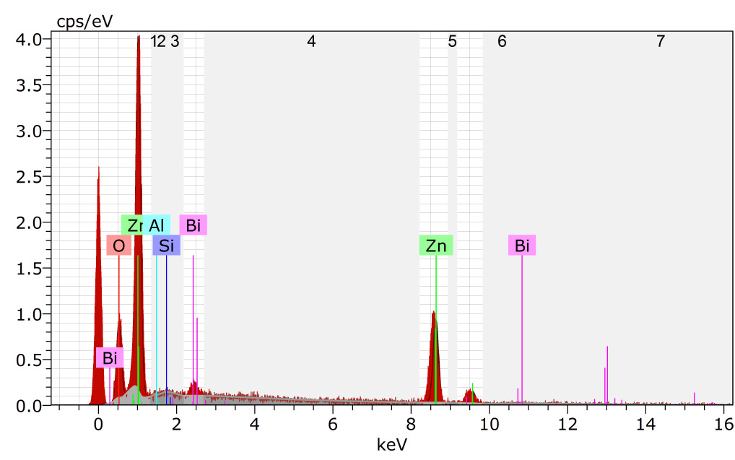

**Fig. SI 3.** EDAX image of Montmorillonite clay

**0**

**20**

**40**

**60**

**80**

**100**

**0**

**15**

**30**

**45**

**60**

**% of Rh-B dye remaining**

**Time (min)**

**(f)**

**(c)**

**(b)**

**(a)**

**(d)**

**(e)**

**Fig. SI 4.** Photodegradability of Rh–B with different catalysts: (a) Dark (b), Catalyst without light (c) Montmorillonite clay (d) Undoped CdAl2O4 (e) 3% wt MMT/CdAl2O4 and (f) 5% wt MMT/CdAl2O4, dye concentration = 3 × 10−4 M, catalyst suspended = 3 g L−1, pH = 7, airflow rate = 8.1 mL s−1, I*UV* = 1.381 × 10−6 einstein L−1 s−1, irradiation time =45 min.